Flickr registration

Added 14.08.2018.

To use the API of Flickr you will need to generate API credentials.

1. Go to the Flickr page <https://www.flickr.com/> and click Sign Up.

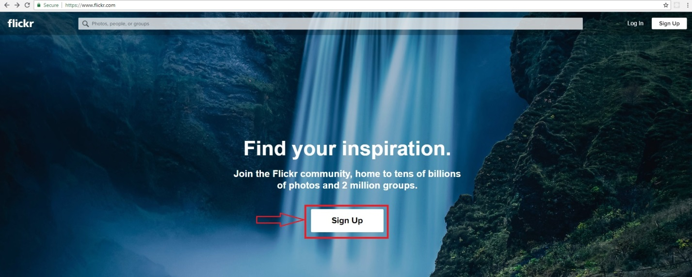

1. Enter information about you and click Continue.

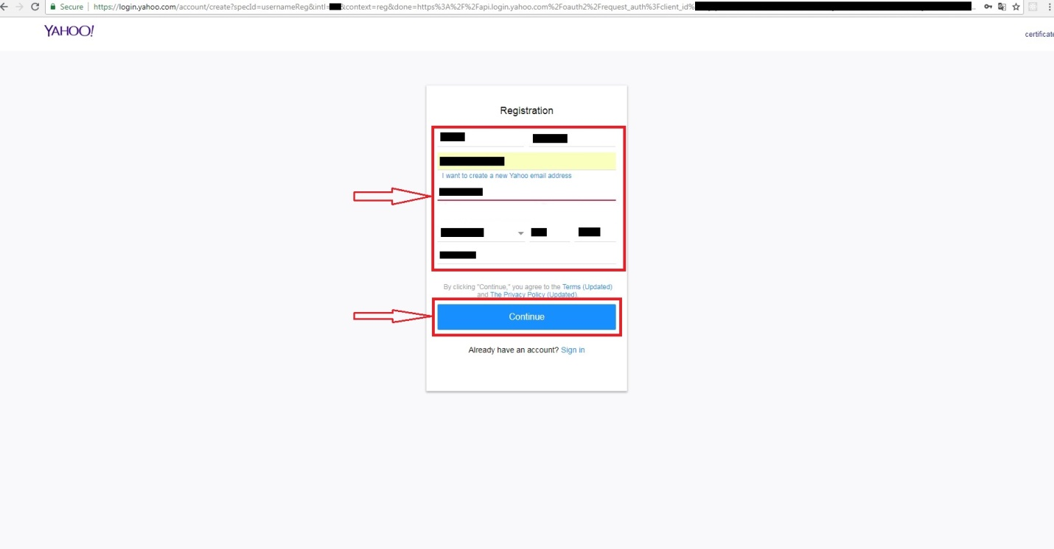

1. You need to verify your e-mail.

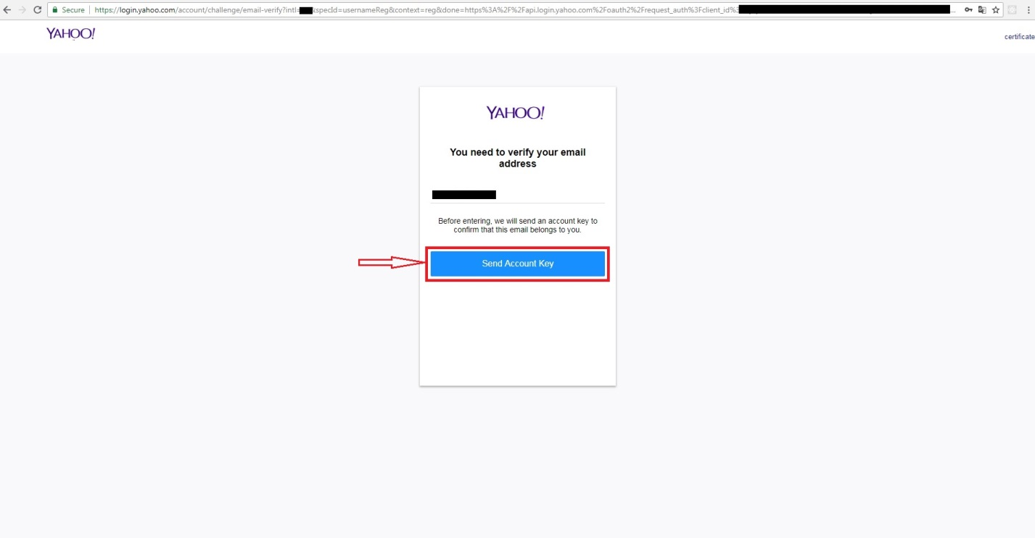

1. On your e-mail account will arrive a letter with the verify account key.

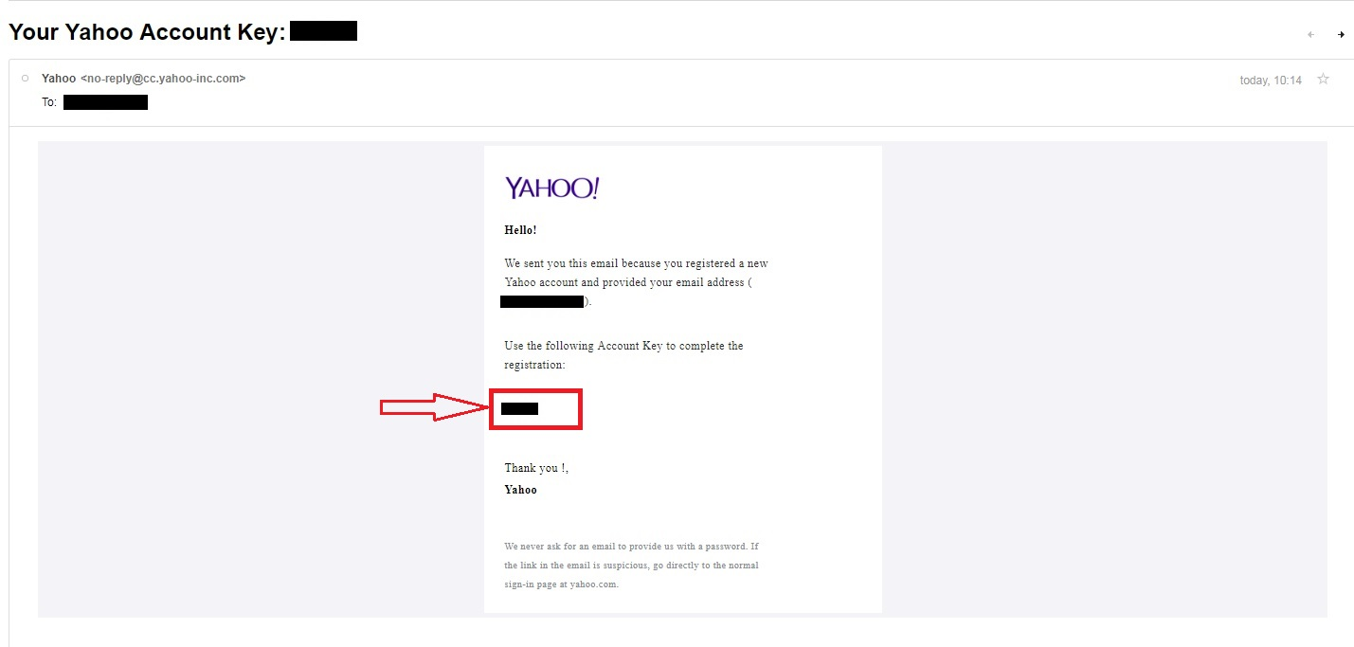

1. You have to enter verify account information in registration page and click Continue.



1. After registration you need to verify information about you and click Next.

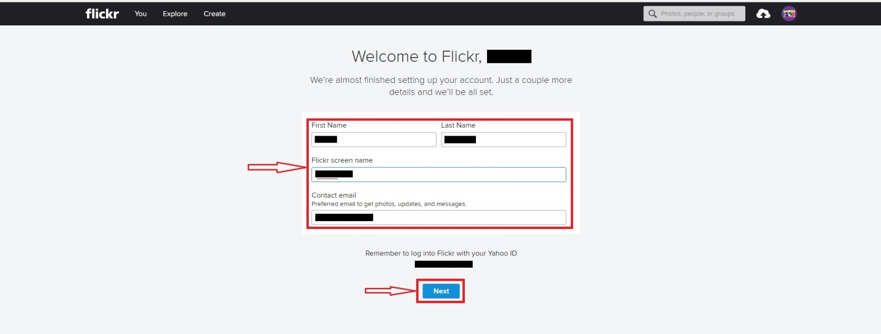

1. To use API you have to request an API Key.

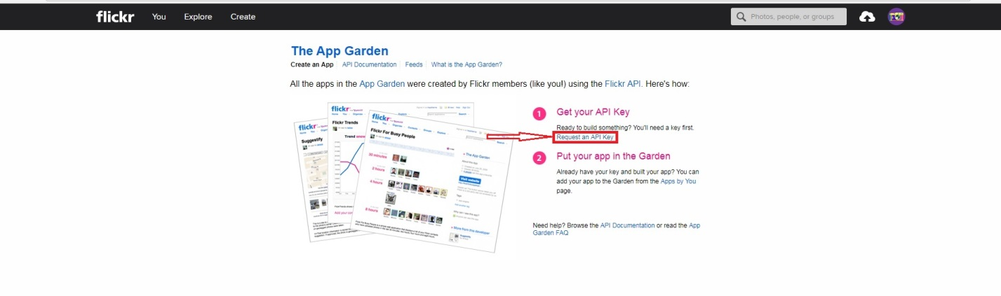

1. You have to choose if your app will be commercial or not.



1. Enter information about you App and click Submit.

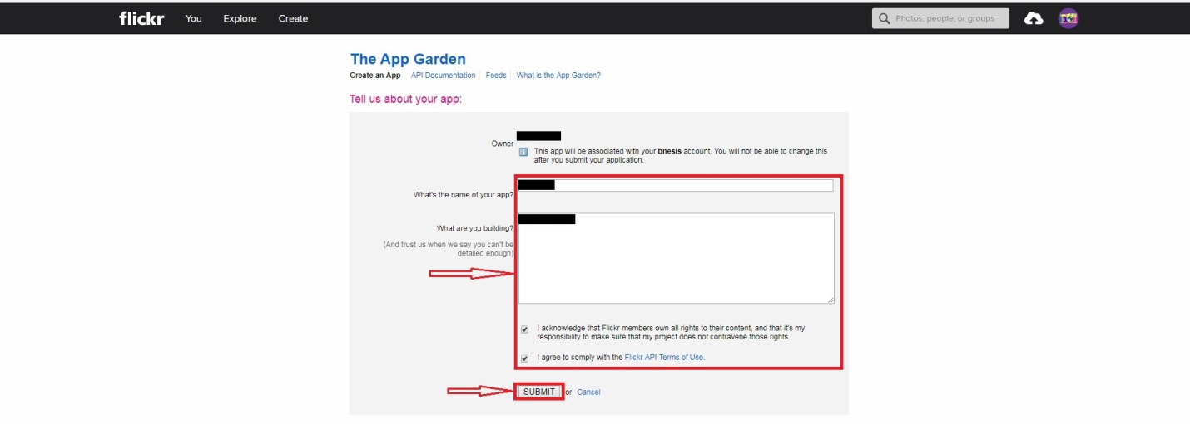

1. Your API Key and Secret.

